Feedback Form

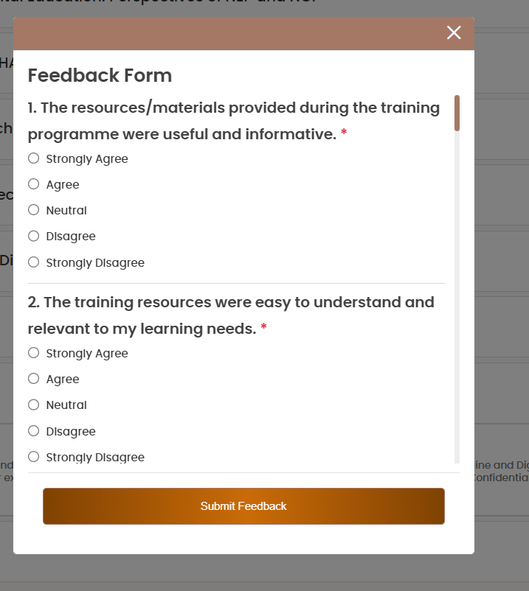
<div class="modal-body give-feedback-modal" id="feedback_content"><div class="feedback-form-container"><h4 class="feedback-head-text">Feedback Form</h4><form id="feedback-submit-form" class="feedback-questions" method="post"><div class="feedback-body custom_scrollbar"><input type="hidden" name="cmid" value="32004"><div class="feedback-item feed-que-div"><div class="que-no">1. The resources/materials provided during the training programme were useful and informative. <span class="text-danger">*</span></div><div class="feed-ans-div"><div class="form-check"><input class="form-check-input" type="radio" name="multichoice_3808" id="multichoice_3808_1" value="1" required=""><label class="form-check-label" for="multichoice_3808_1">Strongly Agree</label></div></div><div class="feed-ans-div"><div class="form-check"><input class="form-check-input" type="radio" name="multichoice_3808" id="multichoice_3808_2" value="2" required=""><label class="form-check-label" for="multichoice_3808_2">Agree</label></div></div><div class="feed-ans-div"><div class="form-check"><input class="form-check-input" type="radio" name="multichoice_3808" id="multichoice_3808_3" value="3" required=""><label class="form-check-label" for="multichoice_3808_3">Neutral</label></div></div><div class="feed-ans-div"><div class="form-check"><input class="form-check-input" type="radio" name="multichoice_3808" id="multichoice_3808_4" value="4" required=""><label class="form-check-label" for="multichoice_3808_4">Disagree</label></div></div><div class="feed-ans-div"><div class="form-check"><input class="form-check-input" type="radio" name="multichoice_3808" id="multichoice_3808_5" value="5" required=""><label class="form-check-label" for="multichoice_3808_5">Strongly Disagree</label></div></div></div><div class="feedback-item feed-que-div"><div class="que-no">2. The training resources were easy to understand and relevant to my learning needs. <span class="text-danger">*</span></div><div class="feed-ans-div"><div class="form-check"><input class="form-check-input" type="radio" name="multichoice_3809" id="multichoice_3809_1" value="1" required=""><label class="form-check-label" for="multichoice_3809_1">Strongly Agree</label></div></div><div class="feed-ans-div"><div class="form-check"><input class="form-check-input" type="radio" name="multichoice_3809" id="multichoice_3809_2" value="2" required=""><label class="form-check-label" for="multichoice_3809_2">Agree</label></div></div><div class="feed-ans-div"><div class="form-check"><input class="form-check-input" type="radio" name="multichoice_3809" id="multichoice_3809_3" value="3" required=""><label class="form-check-label" for="multichoice_3809_3">Neutral</label></div></div><div class="feed-ans-div"><div class="form-check"><input class="form-check-input" type="radio" name="multichoice_3809" id="multichoice_3809_4" value="4" required=""><label class="form-check-label" for="multichoice_3809_4">Disagree</label></div></div><div class="feed-ans-div"><div class="form-check"><input class="form-check-input" type="radio" name="multichoice_3809" id="multichoice_3809_5" value="5" required=""><label class="form-check-label" for="multichoice_3809_5">Strongly Disagree</label></div></div></div><div class="feedback-item feed-que-div"><div class="que-no">3. Time provided to go through the training resources/materials? <span class="text-danger">*</span></div><div class="feed-ans-div"><div class="form-check"><input class="form-check-input" type="radio" name="multichoice_3810" id="multichoice_3810_1" value="1" required=""><label class="form-check-label" for="multichoice_3810_1">Too Long</label></div></div><div class="feed-ans-div"><div class="form-check"><input class="form-check-input" type="radio" name="multichoice_3810" id="multichoice_3810_2" value="2" required=""><label class="form-check-label" for="multichoice_3810_2">Appropriate</label></div></div><div class="feed-ans-div"><div class="form-check"><input class="form-check-input" type="radio" name="multichoice_3810" id="multichoice_3810_3" value="3" required=""><label class="form-check-label" for="multichoice_3810_3">Too Short</label></div></div></div><div class="feedback-item feed-que-div"><div class="que-no">4. The quality and organisation of the training resources supported my overall learning experience. <span class="text-danger">*</span></div><div class="feed-ans-div"><div class="form-check"><input class="form-check-input" type="radio" name="multichoice_3811" id="multichoice_3811_1" value="1" required=""><label class="form-check-label" for="multichoice_3811_1">Strongly Agree</label></div></div><div class="feed-ans-div"><div class="form-check"><input class="form-check-input" type="radio" name="multichoice_3811" id="multichoice_3811_2" value="2" required=""><label class="form-check-label" for="multichoice_3811_2">Agree</label></div></div><div class="feed-ans-div"><div class="form-check"><input class="form-check-input" type="radio" name="multichoice_3811" id="multichoice_3811_3" value="3" required=""><label class="form-check-label" for="multichoice_3811_3">Neutral</label></div></div><div class="feed-ans-div"><div class="form-check"><input class="form-check-input" type="radio" name="multichoice_3811" id="multichoice_3811_4" value="4" required=""><label class="form-check-label" for="multichoice_3811_4">Disagree</label></div></div><div class="feed-ans-div"><div class="form-check"><input class="form-check-input" type="radio" name="multichoice_3811" id="multichoice_3811_5" value="5" required=""><label class="form-check-label" for="multichoice_3811_5">Strongly Disagree</label></div></div></div><div class="feedback-item feed-que-div"><div class="que-no">5. The content provided during the training can be effectively used in my professional practice/work. <span class="text-danger">*</span></div><div class="feed-ans-div"><div class="form-check"><input class="form-check-input" type="radio" name="multichoice_3812" id="multichoice_3812_1" value="1" required=""><label class="form-check-label" for="multichoice_3812_1">Strongly Agree</label></div></div><div class="feed-ans-div"><div class="form-check"><input class="form-check-input" type="radio" name="multichoice_3812" id="multichoice_3812_2" value="2" required=""><label class="form-check-label" for="multichoice_3812_2">Agree</label></div></div><div class="feed-ans-div"><div class="form-check"><input class="form-check-input" type="radio" name="multichoice_3812" id="multichoice_3812_3" value="3" required=""><label class="form-check-label" for="multichoice_3812_3">Neutral</label></div></div><div class="feed-ans-div"><div class="form-check"><input class="form-check-input" type="radio" name="multichoice_3812" id="multichoice_3812_4" value="4" required=""><label class="form-check-label" for="multichoice_3812_4">Disagree</label></div></div><div class="feed-ans-div"><div class="form-check"><input class="form-check-input" type="radio" name="multichoice_3812" id="multichoice_3812_5" value="5" required=""><label class="form-check-label" for="multichoice_3812_5">Strongly Disagree</label></div></div></div><div class="feedback-item feed-que-div"><div class="que-no">6. The resource person explained the concepts clearly and effectively. <span class="text-danger">*</span></div><div class="feed-ans-div"><div class="form-check"><input class="form-check-input" type="radio" name="multichoice_3813" id="multichoice_3813_1" value="1" required=""><label class="form-check-label" for="multichoice_3813_1">Strongly Agree</label></div></div><div class="feed-ans-div"><div class="form-check"><input class="form-check-input" type="radio" name="multichoice_3813" id="multichoice_3813_2" value="2" required=""><label class="form-check-label" for="multichoice_3813_2">Agree</label></div></div><div class="feed-ans-div"><div class="form-check"><input class="form-check-input" type="radio" name="multichoice_3813" id="multichoice_3813_3" value="3" required=""><label class="form-check-label" for="multichoice_3813_3">Neutral</label></div></div><div class="feed-ans-div"><div class="form-check"><input class="form-check-input" type="radio" name="multichoice_3813" id="multichoice_3813_4" value="4" required=""><label class="form-check-label" for="multichoice_3813_4">Disagree</label></div></div><div class="feed-ans-div"><div class="form-check"><input class="form-check-input" type="radio" name="multichoice_3813" id="multichoice_3813_5" value="5" required=""><label class="form-check-label" for="multichoice_3813_5">Strongly Disagree</label></div></div></div><div class="feedback-item feed-que-div"><div class="que-no">7. The Resource Person provided relevant examples and practical insights related to the topic. <span class="text-danger">*</span></div><div class="feed-ans-div"><div class="form-check"><input class="form-check-input" type="radio" name="multichoice_3814" id="multichoice_3814_1" value="1" required=""><label class="form-check-label" for="multichoice_3814_1">Strongly Agree</label></div></div><div class="feed-ans-div"><div class="form-check"><input class="form-check-input" type="radio" name="multichoice_3814" id="multichoice_3814_2" value="2" required=""><label class="form-check-label" for="multichoice_3814_2">Agree</label></div></div><div class="feed-ans-div"><div class="form-check"><input class="form-check-input" type="radio" name="multichoice_3814" id="multichoice_3814_3" value="3" required=""><label class="form-check-label" for="multichoice_3814_3">Neutral</label></div></div><div class="feed-ans-div"><div class="form-check"><input class="form-check-input" type="radio" name="multichoice_3814" id="multichoice_3814_4" value="4" required=""><label class="form-check-label" for="multichoice_3814_4">Disagree</label></div></div><div class="feed-ans-div"><div class="form-check"><input class="form-check-input" type="radio" name="multichoice_3814" id="multichoice_3814_5" value="5" required=""><label class="form-check-label" for="multichoice_3814_5">Strongly Disagree</label></div></div></div><div class="feedback-item feed-que-div"><div class="que-no">8. The resource person used appropriate teaching methods and communication techniques during the sessions. <span class="text-danger">*</span></div><div class="feed-ans-div"><div class="form-check"><input class="form-check-input" type="radio" name="multichoice_3815" id="multichoice_3815_1" value="1" required=""><label class="form-check-label" for="multichoice_3815_1">Strongly Agree</label></div></div><div class="feed-ans-div"><div class="form-check"><input class="form-check-input" type="radio" name="multichoice_3815" id="multichoice_3815_2" value="2" required=""><label class="form-check-label" for="multichoice_3815_2">Agree</label></div></div><div class="feed-ans-div"><div class="form-check"><input class="form-check-input" type="radio" name="multichoice_3815" id="multichoice_3815_3" value="3" required=""><label class="form-check-label" for="multichoice_3815_3">Neutral</label></div></div><div class="feed-ans-div"><div class="form-check"><input class="form-check-input" type="radio" name="multichoice_3815" id="multichoice_3815_4" value="4" required=""><label class="form-check-label" for="multichoice_3815_4">Disagree</label></div></div><div class="feed-ans-div"><div class="form-check"><input class="form-check-input" type="radio" name="multichoice_3815" id="multichoice_3815_5" value="5" required=""><label class="form-check-label" for="multichoice_3815_5">Strongly Disagree</label></div></div></div><div class="feedback-item feed-que-div"><div class="que-no">9. The sessions conducted by the resource person were engaging and useful for professional learning. <span class="text-danger">*</span></div><div class="feed-ans-div"><div class="form-check"><input class="form-check-input" type="radio" name="multichoice_3816" id="multichoice_3816_1" value="1" required=""><label class="form-check-label" for="multichoice_3816_1">Strongly Agree</label></div></div><div class="feed-ans-div"><div class="form-check"><input class="form-check-input" type="radio" name="multichoice_3816" id="multichoice_3816_2" value="2" required=""><label class="form-check-label" for="multichoice_3816_2">Agree</label></div></div><div class="feed-ans-div"><div class="form-check"><input class="form-check-input" type="radio" name="multichoice_3816" id="multichoice_3816_3" value="3" required=""><label class="form-check-label" for="multichoice_3816_3">Neutral</label></div></div><div class="feed-ans-div"><div class="form-check"><input class="form-check-input" type="radio" name="multichoice_3816" id="multichoice_3816_4" value="4" required=""><label class="form-check-label" for="multichoice_3816_4">Disagree</label></div></div><div class="feed-ans-div"><div class="form-check"><input class="form-check-input" type="radio" name="multichoice_3816" id="multichoice_3816_5" value="5" required=""><label class="form-check-label" for="multichoice_3816_5">Strongly Disagree</label></div></div></div><div class="feedback-item feed-que-div"><div class="que-no">10. How would you rate the overall delivery of the sessions by the Resource Person? <span class="text-danger">*</span></div><div class="feed-ans-div"><div class="form-check"><input class="form-check-input" type="radio" name="multichoice_3817" id="multichoice_3817_1" value="1" required=""><label class="form-check-label" for="multichoice_3817_1">Excellent</label></div></div><div class="feed-ans-div"><div class="form-check"><input class="form-check-input" type="radio" name="multichoice_3817" id="multichoice_3817_2" value="2" required=""><label class="form-check-label" for="multichoice_3817_2">Good</label></div></div><div class="feed-ans-div"><div class="form-check"><input class="form-check-input" type="radio" name="multichoice_3817" id="multichoice_3817_3" value="3" required=""><label class="form-check-label" for="multichoice_3817_3">Average</label></div></div><div class="feed-ans-div"><div class="form-check"><input class="form-check-input" type="radio" name="multichoice_3817" id="multichoice_3817_4" value="4" required=""><label class="form-check-label" for="multichoice_3817_4">Poor</label></div></div></div><div class="feedback-item feed-que-div"><div class="que-no">11. The content covered in the training programme was relevant to my professional needs. <span class="text-danger">*</span></div><div class="feed-ans-div"><div class="form-check"><input class="form-check-input" type="radio" name="multichoice_3818" id="multichoice_3818_1" value="1" required=""><label class="form-check-label" for="multichoice_3818_1">Strongly Agree</label></div></div><div class="feed-ans-div"><div class="form-check"><input class="form-check-input" type="radio" name="multichoice_3818" id="multichoice_3818_2" value="2" required=""><label class="form-check-label" for="multichoice_3818_2">Agree</label></div></div><div class="feed-ans-div"><div class="form-check"><input class="form-check-input" type="radio" name="multichoice_3818" id="multichoice_3818_3" value="3" required=""><label class="form-check-label" for="multichoice_3818_3">Neutral</label></div></div><div class="feed-ans-div"><div class="form-check"><input class="form-check-input" type="radio" name="multichoice_3818" id="multichoice_3818_4" value="4" required=""><label class="form-check-label" for="multichoice_3818_4">Disagree</label></div></div><div class="feed-ans-div"><div class="form-check"><input class="form-check-input" type="radio" name="multichoice_3818" id="multichoice_3818_5" value="5" required=""><label class="form-check-label" for="multichoice_3818_5">Strongly Disagree</label></div></div></div><div class="feedback-item feed-que-div"><div class="que-no">12. The content was well-structured and organised in a logical manner. <span class="text-danger">*</span></div><div class="feed-ans-div"><div class="form-check"><input class="form-check-input" type="radio" name="multichoice_3819" id="multichoice_3819_1" value="1" required=""><label class="form-check-label" for="multichoice_3819_1">Strongly Agree</label></div></div><div class="feed-ans-div"><div class="form-check"><input class="form-check-input" type="radio" name="multichoice_3819" id="multichoice_3819_2" value="2" required=""><label class="form-check-label" for="multichoice_3819_2">Agree</label></div></div><div class="feed-ans-div"><div class="form-check"><input class="form-check-input" type="radio" name="multichoice_3819" id="multichoice_3819_3" value="3" required=""><label class="form-check-label" for="multichoice_3819_3">Neutral</label></div></div><div class="feed-ans-div"><div class="form-check"><input class="form-check-input" type="radio" name="multichoice_3819" id="multichoice_3819_4" value="4" required=""><label class="form-check-label" for="multichoice_3819_4">Disagree</label></div></div><div class="feed-ans-div"><div class="form-check"><input class="form-check-input" type="radio" name="multichoice_3819" id="multichoice_3819_5" value="5" required=""><label class="form-check-label" for="multichoice_3819_5">Strongly Disagree</label></div></div></div><div class="feedback-item feed-que-div"><div class="que-no">13. The depth and scope of the content were appropriate for the training objectives. <span class="text-danger">*</span></div><div class="feed-ans-div"><div class="form-check"><input class="form-check-input" type="radio" name="multichoice_3820" id="multichoice_3820_1" value="1" required=""><label class="form-check-label" for="multichoice_3820_1">Strongly Agree</label></div></div><div class="feed-ans-div"><div class="form-check"><input class="form-check-input" type="radio" name="multichoice_3820" id="multichoice_3820_2" value="2" required=""><label class="form-check-label" for="multichoice_3820_2">Agree</label></div></div><div class="feed-ans-div"><div class="form-check"><input class="form-check-input" type="radio" name="multichoice_3820" id="multichoice_3820_3" value="3" required=""><label class="form-check-label" for="multichoice_3820_3">Neutral</label></div></div><div class="feed-ans-div"><div class="form-check"><input class="form-check-input" type="radio" name="multichoice_3820" id="multichoice_3820_4" value="4" required=""><label class="form-check-label" for="multichoice_3820_4">Disagree</label></div></div><div class="feed-ans-div"><div class="form-check"><input class="form-check-input" type="radio" name="multichoice_3820" id="multichoice_3820_5" value="5" required=""><label class="form-check-label" for="multichoice_3820_5">Strongly Disagree</label></div></div></div><div class="feedback-item feed-que-div"><div class="que-no">14. The content provided practical knowledge and useful insights for application in work/teaching. <span class="text-danger">*</span></div><div class="feed-ans-div"><div class="form-check"><input class="form-check-input" type="radio" name="multichoice_3821" id="multichoice_3821_1" value="1" required=""><label class="form-check-label" for="multichoice_3821_1">Strongly Agree</label></div></div><div class="feed-ans-div"><div class="form-check"><input class="form-check-input" type="radio" name="multichoice_3821" id="multichoice_3821_2" value="2" required=""><label class="form-check-label" for="multichoice_3821_2">Agree</label></div></div><div class="feed-ans-div"><div class="form-check"><input class="form-check-input" type="radio" name="multichoice_3821" id="multichoice_3821_3" value="3" required=""><label class="form-check-label" for="multichoice_3821_3">Neutral</label></div></div><div class="feed-ans-div"><div class="form-check"><input class="form-check-input" type="radio" name="multichoice_3821" id="multichoice_3821_4" value="4" required=""><label class="form-check-label" for="multichoice_3821_4">Disagree</label></div></div><div class="feed-ans-div"><div class="form-check"><input class="form-check-input" type="radio" name="multichoice_3821" id="multichoice_3821_5" value="5" required=""><label class="form-check-label" for="multichoice_3821_5">Strongly Disagree</label></div></div></div><div class="feedback-item feed-que-div"><div class="que-no">15. The training content enhanced my understanding of the topic effectively. <span class="text-danger">*</span></div><div class="feed-ans-div"><div class="form-check"><input class="form-check-input" type="radio" name="multichoice_3822" id="multichoice_3822_1" value="1" required=""><label class="form-check-label" for="multichoice_3822_1">Strongly Agree</label></div></div><div class="feed-ans-div"><div class="form-check"><input class="form-check-input" type="radio" name="multichoice_3822" id="multichoice_3822_2" value="2" required=""><label class="form-check-label" for="multichoice_3822_2">Agree</label></div></div><div class="feed-ans-div"><div class="form-check"><input class="form-check-input" type="radio" name="multichoice_3822" id="multichoice_3822_3" value="3" required=""><label class="form-check-label" for="multichoice_3822_3">Neutral</label></div></div><div class="feed-ans-div"><div class="form-check"><input class="form-check-input" type="radio" name="multichoice_3822" id="multichoice_3822_4" value="4" required=""><label class="form-check-label" for="multichoice_3822_4">Disagree</label></div></div><div class="feed-ans-div"><div class="form-check"><input class="form-check-input" type="radio" name="multichoice_3822" id="multichoice_3822_5" value="5" required=""><label class="form-check-label" for="multichoice_3822_5">Strongly Disagree</label></div></div></div><div class="feedback-item feed-que-div"><div class="que-no">16. How would you rate your overall experience of the training? <span class="text-danger">*</span></div><div class="feed-ans-div"><div class="form-check"><input class="form-check-input" type="radio" name="multichoice_3823" id="multichoice_3823_1" value="1" required=""><label class="form-check-label" for="multichoice_3823_1">Excellent</label></div></div><div class="feed-ans-div"><div class="form-check"><input class="form-check-input" type="radio" name="multichoice_3823" id="multichoice_3823_2" value="2" required=""><label class="form-check-label" for="multichoice_3823_2">Good</label></div></div><div class="feed-ans-div"><div class="form-check"><input class="form-check-input" type="radio" name="multichoice_3823" id="multichoice_3823_3" value="3" required=""><label class="form-check-label" for="multichoice_3823_3">Average</label></div></div><div class="feed-ans-div"><div class="form-check"><input class="form-check-input" type="radio" name="multichoice_3823" id="multichoice_3823_4" value="4" required=""><label class="form-check-label" for="multichoice_3823_4">Poor</label></div></div><div class="feed-ans-div"><div class="form-check"><input class="form-check-input" type="radio" name="multichoice_3823" id="multichoice_3823_5" value="5" required=""><label class="form-check-label" for="multichoice_3823_5">Very Poor</label></div></div></div><div class="feedback-item feed-que-div"><div class="que-no">17. Would you recommend this training programme to others? <span class="text-danger">*</span></div><div class="feed-ans-div"><div class="form-check"><input class="form-check-input" type="radio" name="multichoice_3824" id="multichoice_3824_1" value="1" required=""><label class="form-check-label" for="multichoice_3824_1">Yes</label></div></div><div class="feed-ans-div"><div class="form-check"><input class="form-check-input" type="radio" name="multichoice_3824" id="multichoice_3824_2" value="2" required=""><label class="form-check-label" for="multichoice_3824_2">Maybe</label></div></div><div class="feed-ans-div"><div class="form-check"><input class="form-check-input" type="radio" name="multichoice_3824" id="multichoice_3824_3" value="3" required=""><label class="form-check-label" for="multichoice_3824_3">No</label></div></div></div><div class="feedback-item feed-que-div"><div class="que-no">18. Was the training duration appropriate for the content covered? <span class="text-danger">*</span></div><div class="feed-ans-div"><div class="form-check"><input class="form-check-input" type="radio" name="multichoice_3825" id="multichoice_3825_1" value="1" required=""><label class="form-check-label" for="multichoice_3825_1">Yes</label></div></div><div class="feed-ans-div"><div class="form-check"><input class="form-check-input" type="radio" name="multichoice_3825" id="multichoice_3825_2" value="2" required=""><label class="form-check-label" for="multichoice_3825_2">No</label></div></div></div><div class="feedback-item feed-que-div"><div class="que-no">19. What aspects of the training could be improved? <span class="text-danger">*</span></div><div class="feed-ans-div"><textarea class="form-control" name="textarea_3826" rows="4" required=""></textarea></div></div><div class="feedback-item feed-que-div"><div class="que-no">20. What constraints/challenges did you face while attending the sessions? <span class="text-danger">*</span></div><div class="feed-ans-div"><textarea class="form-control" name="textarea_3827" rows="4" required=""></textarea></div></div><div class="feedback-item feed-que-div"><div class="que-no">21. Please provide any additional comments or suggestions to enhance the training experience. <span class="text-danger">*</span></div><div class="feed-ans-div"><textarea class="form-control" name="textarea_3828" rows="4" required=""></textarea></div></div></div><div class="modal-footer justify-content-center"><button type="submit" class="btn btn-primary w-100 submit-feed-btn" id="submitFeedbackBtn11">Submit Feedback</button></div></form></div></div>

For close

<a href="#" data-dismiss="modal" aria-label="Close">
<i class="icon-pre-cancel close_icon" aria-hidden="true"></i>
</a>

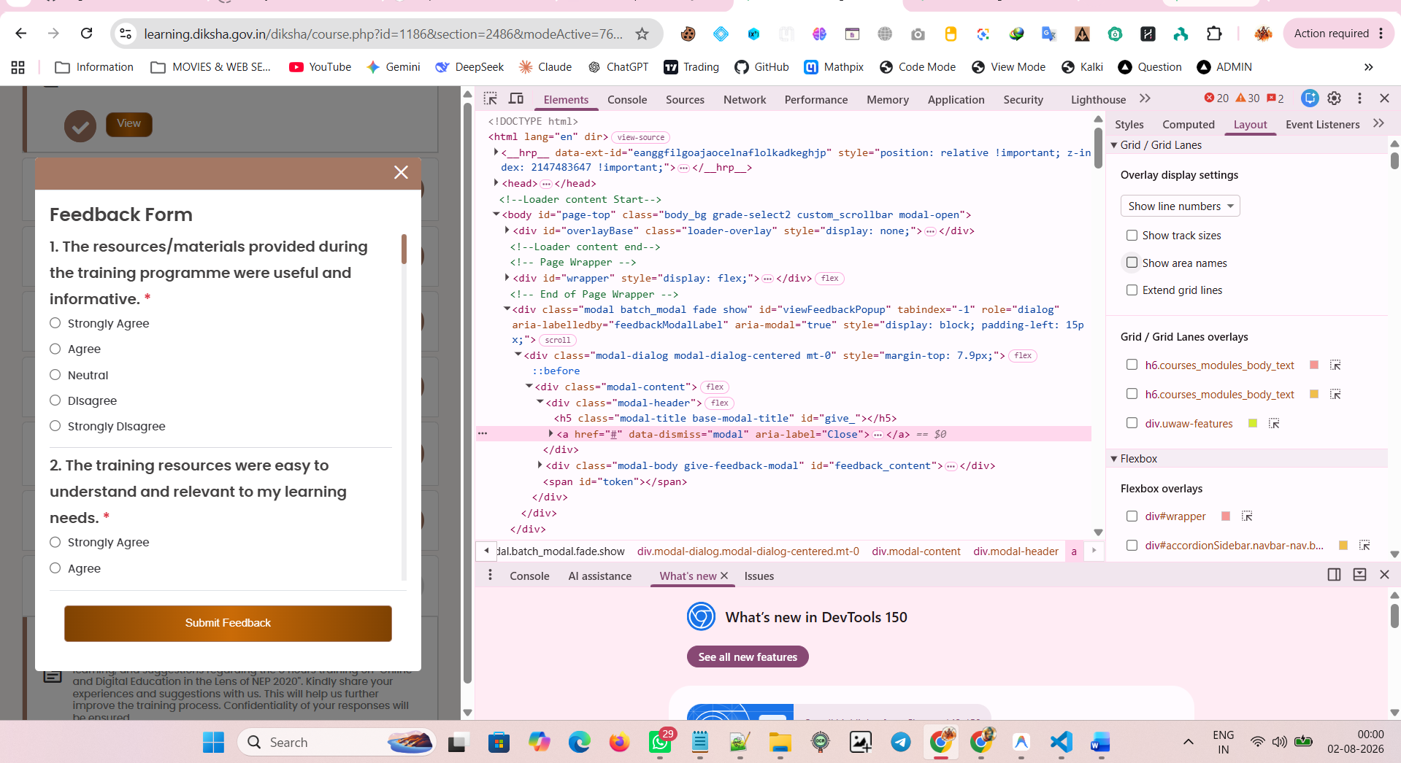

SCROLL BAR

<div class="feedback-body custom_scrollbar"><input type="hidden" name="cmid" value="32004"><div class="feedback-item feed-que-div"><div class="que-no">1. The resources/materials provided during the training programme were useful and informative. <span class="text-danger">*</span></div><div class="feed-ans-div"><div class="form-check"><input class="form-check-input" type="radio" name="multichoice_3808" id="multichoice_3808_1" value="1" required=""><label class="form-check-label" for="multichoice_3808_1">Strongly Agree</label></div></div><div class="feed-ans-div"><div class="form-check"><input class="form-check-input" type="radio" name="multichoice_3808" id="multichoice_3808_2" value="2" required=""><label class="form-check-label" for="multichoice_3808_2">Agree</label></div></div><div class="feed-ans-div"><div class="form-check"><input class="form-check-input" type="radio" name="multichoice_3808" id="multichoice_3808_3" value="3" required=""><label class="form-check-label" for="multichoice_3808_3">Neutral</label></div></div><div class="feed-ans-div"><div class="form-check"><input class="form-check-input" type="radio" name="multichoice_3808" id="multichoice_3808_4" value="4" required=""><label class="form-check-label" for="multichoice_3808_4">Disagree</label></div></div><div class="feed-ans-div"><div class="form-check"><input class="form-check-input" type="radio" name="multichoice_3808" id="multichoice_3808_5" value="5" required=""><label class="form-check-label" for="multichoice_3808_5">Strongly Disagree</label></div></div></div><div class="feedback-item feed-que-div"><div class="que-no">2. The training resources were easy to understand and relevant to my learning needs. <span class="text-danger">*</span></div><div class="feed-ans-div"><div class="form-check"><input class="form-check-input" type="radio" name="multichoice_3809" id="multichoice_3809_1" value="1" required=""><label class="form-check-label" for="multichoice_3809_1">Strongly Agree</label></div></div><div class="feed-ans-div"><div class="form-check"><input class="form-check-input" type="radio" name="multichoice_3809" id="multichoice_3809_2" value="2" required=""><label class="form-check-label" for="multichoice_3809_2">Agree</label></div></div><div class="feed-ans-div"><div class="form-check"><input class="form-check-input" type="radio" name="multichoice_3809" id="multichoice_3809_3" value="3" required=""><label class="form-check-label" for="multichoice_3809_3">Neutral</label></div></div><div class="feed-ans-div"><div class="form-check"><input class="form-check-input" type="radio" name="multichoice_3809" id="multichoice_3809_4" value="4" required=""><label class="form-check-label" for="multichoice_3809_4">Disagree</label></div></div><div class="feed-ans-div"><div class="form-check"><input class="form-check-input" type="radio" name="multichoice_3809" id="multichoice_3809_5" value="5" required=""><label class="form-check-label" for="multichoice_3809_5">Strongly Disagree</label></div></div></div><div class="feedback-item feed-que-div"><div class="que-no">3. Time provided to go through the training resources/materials? <span class="text-danger">*</span></div><div class="feed-ans-div"><div class="form-check"><input class="form-check-input" type="radio" name="multichoice_3810" id="multichoice_3810_1" value="1" required=""><label class="form-check-label" for="multichoice_3810_1">Too Long</label></div></div><div class="feed-ans-div"><div class="form-check"><input class="form-check-input" type="radio" name="multichoice_3810" id="multichoice_3810_2" value="2" required=""><label class="form-check-label" for="multichoice_3810_2">Appropriate</label></div></div><div class="feed-ans-div"><div class="form-check"><input class="form-check-input" type="radio" name="multichoice_3810" id="multichoice_3810_3" value="3" required=""><label class="form-check-label" for="multichoice_3810_3">Too Short</label></div></div></div><div class="feedback-item feed-que-div"><div class="que-no">4. The quality and organisation of the training resources supported my overall learning experience. <span class="text-danger">*</span></div><div class="feed-ans-div"><div class="form-check"><input class="form-check-input" type="radio" name="multichoice_3811" id="multichoice_3811_1" value="1" required=""><label class="form-check-label" for="multichoice_3811_1">Strongly Agree</label></div></div><div class="feed-ans-div"><div class="form-check"><input class="form-check-input" type="radio" name="multichoice_3811" id="multichoice_3811_2" value="2" required=""><label class="form-check-label" for="multichoice_3811_2">Agree</label></div></div><div class="feed-ans-div"><div class="form-check"><input class="form-check-input" type="radio" name="multichoice_3811" id="multichoice_3811_3" value="3" required=""><label class="form-check-label" for="multichoice_3811_3">Neutral</label></div></div><div class="feed-ans-div"><div class="form-check"><input class="form-check-input" type="radio" name="multichoice_3811" id="multichoice_3811_4" value="4" required=""><label class="form-check-label" for="multichoice_3811_4">Disagree</label></div></div><div class="feed-ans-div"><div class="form-check"><input class="form-check-input" type="radio" name="multichoice_3811" id="multichoice_3811_5" value="5" required=""><label class="form-check-label" for="multichoice_3811_5">Strongly Disagree</label></div></div></div><div class="feedback-item feed-que-div"><div class="que-no">5. The content provided during the training can be effectively used in my professional practice/work. <span class="text-danger">*</span></div><div class="feed-ans-div"><div class="form-check"><input class="form-check-input" type="radio" name="multichoice_3812" id="multichoice_3812_1" value="1" required=""><label class="form-check-label" for="multichoice_3812_1">Strongly Agree</label></div></div><div class="feed-ans-div"><div class="form-check"><input class="form-check-input" type="radio" name="multichoice_3812" id="multichoice_3812_2" value="2" required=""><label class="form-check-label" for="multichoice_3812_2">Agree</label></div></div><div class="feed-ans-div"><div class="form-check"><input class="form-check-input" type="radio" name="multichoice_3812" id="multichoice_3812_3" value="3" required=""><label class="form-check-label" for="multichoice_3812_3">Neutral</label></div></div><div class="feed-ans-div"><div class="form-check"><input class="form-check-input" type="radio" name="multichoice_3812" id="multichoice_3812_4" value="4" required=""><label class="form-check-label" for="multichoice_3812_4">Disagree</label></div></div><div class="feed-ans-div"><div class="form-check"><input class="form-check-input" type="radio" name="multichoice_3812" id="multichoice_3812_5" value="5" required=""><label class="form-check-label" for="multichoice_3812_5">Strongly Disagree</label></div></div></div><div class="feedback-item feed-que-div"><div class="que-no">6. The resource person explained the concepts clearly and effectively. <span class="text-danger">*</span></div><div class="feed-ans-div"><div class="form-check"><input class="form-check-input" type="radio" name="multichoice_3813" id="multichoice_3813_1" value="1" required=""><label class="form-check-label" for="multichoice_3813_1">Strongly Agree</label></div></div><div class="feed-ans-div"><div class="form-check"><input class="form-check-input" type="radio" name="multichoice_3813" id="multichoice_3813_2" value="2" required=""><label class="form-check-label" for="multichoice_3813_2">Agree</label></div></div><div class="feed-ans-div"><div class="form-check"><input class="form-check-input" type="radio" name="multichoice_3813" id="multichoice_3813_3" value="3" required=""><label class="form-check-label" for="multichoice_3813_3">Neutral</label></div></div><div class="feed-ans-div"><div class="form-check"><input class="form-check-input" type="radio" name="multichoice_3813" id="multichoice_3813_4" value="4" required=""><label class="form-check-label" for="multichoice_3813_4">Disagree</label></div></div><div class="feed-ans-div"><div class="form-check"><input class="form-check-input" type="radio" name="multichoice_3813" id="multichoice_3813_5" value="5" required=""><label class="form-check-label" for="multichoice_3813_5">Strongly Disagree</label></div></div></div><div class="feedback-item feed-que-div"><div class="que-no">7. The Resource Person provided relevant examples and practical insights related to the topic. <span class="text-danger">*</span></div><div class="feed-ans-div"><div class="form-check"><input class="form-check-input" type="radio" name="multichoice_3814" id="multichoice_3814_1" value="1" required=""><label class="form-check-label" for="multichoice_3814_1">Strongly Agree</label></div></div><div class="feed-ans-div"><div class="form-check"><input class="form-check-input" type="radio" name="multichoice_3814" id="multichoice_3814_2" value="2" required=""><label class="form-check-label" for="multichoice_3814_2">Agree</label></div></div><div class="feed-ans-div"><div class="form-check"><input class="form-check-input" type="radio" name="multichoice_3814" id="multichoice_3814_3" value="3" required=""><label class="form-check-label" for="multichoice_3814_3">Neutral</label></div></div><div class="feed-ans-div"><div class="form-check"><input class="form-check-input" type="radio" name="multichoice_3814" id="multichoice_3814_4" value="4" required=""><label class="form-check-label" for="multichoice_3814_4">Disagree</label></div></div><div class="feed-ans-div"><div class="form-check"><input class="form-check-input" type="radio" name="multichoice_3814" id="multichoice_3814_5" value="5" required=""><label class="form-check-label" for="multichoice_3814_5">Strongly Disagree</label></div></div></div><div class="feedback-item feed-que-div"><div class="que-no">8. The resource person used appropriate teaching methods and communication techniques during the sessions. <span class="text-danger">*</span></div><div class="feed-ans-div"><div class="form-check"><input class="form-check-input" type="radio" name="multichoice_3815" id="multichoice_3815_1" value="1" required=""><label class="form-check-label" for="multichoice_3815_1">Strongly Agree</label></div></div><div class="feed-ans-div"><div class="form-check"><input class="form-check-input" type="radio" name="multichoice_3815" id="multichoice_3815_2" value="2" required=""><label class="form-check-label" for="multichoice_3815_2">Agree</label></div></div><div class="feed-ans-div"><div class="form-check"><input class="form-check-input" type="radio" name="multichoice_3815" id="multichoice_3815_3" value="3" required=""><label class="form-check-label" for="multichoice_3815_3">Neutral</label></div></div><div class="feed-ans-div"><div class="form-check"><input class="form-check-input" type="radio" name="multichoice_3815" id="multichoice_3815_4" value="4" required=""><label class="form-check-label" for="multichoice_3815_4">Disagree</label></div></div><div class="feed-ans-div"><div class="form-check"><input class="form-check-input" type="radio" name="multichoice_3815" id="multichoice_3815_5" value="5" required=""><label class="form-check-label" for="multichoice_3815_5">Strongly Disagree</label></div></div></div><div class="feedback-item feed-que-div"><div class="que-no">9. The sessions conducted by the resource person were engaging and useful for professional learning. <span class="text-danger">*</span></div><div class="feed-ans-div"><div class="form-check"><input class="form-check-input" type="radio" name="multichoice_3816" id="multichoice_3816_1" value="1" required=""><label class="form-check-label" for="multichoice_3816_1">Strongly Agree</label></div></div><div class="feed-ans-div"><div class="form-check"><input class="form-check-input" type="radio" name="multichoice_3816" id="multichoice_3816_2" value="2" required=""><label class="form-check-label" for="multichoice_3816_2">Agree</label></div></div><div class="feed-ans-div"><div class="form-check"><input class="form-check-input" type="radio" name="multichoice_3816" id="multichoice_3816_3" value="3" required=""><label class="form-check-label" for="multichoice_3816_3">Neutral</label></div></div><div class="feed-ans-div"><div class="form-check"><input class="form-check-input" type="radio" name="multichoice_3816" id="multichoice_3816_4" value="4" required=""><label class="form-check-label" for="multichoice_3816_4">Disagree</label></div></div><div class="feed-ans-div"><div class="form-check"><input class="form-check-input" type="radio" name="multichoice_3816" id="multichoice_3816_5" value="5" required=""><label class="form-check-label" for="multichoice_3816_5">Strongly Disagree</label></div></div></div><div class="feedback-item feed-que-div"><div class="que-no">10. How would you rate the overall delivery of the sessions by the Resource Person? <span class="text-danger">*</span></div><div class="feed-ans-div"><div class="form-check"><input class="form-check-input" type="radio" name="multichoice_3817" id="multichoice_3817_1" value="1" required=""><label class="form-check-label" for="multichoice_3817_1">Excellent</label></div></div><div class="feed-ans-div"><div class="form-check"><input class="form-check-input" type="radio" name="multichoice_3817" id="multichoice_3817_2" value="2" required=""><label class="form-check-label" for="multichoice_3817_2">Good</label></div></div><div class="feed-ans-div"><div class="form-check"><input class="form-check-input" type="radio" name="multichoice_3817" id="multichoice_3817_3" value="3" required=""><label class="form-check-label" for="multichoice_3817_3">Average</label></div></div><div class="feed-ans-div"><div class="form-check"><input class="form-check-input" type="radio" name="multichoice_3817" id="multichoice_3817_4" value="4" required=""><label class="form-check-label" for="multichoice_3817_4">Poor</label></div></div></div><div class="feedback-item feed-que-div"><div class="que-no">11. The content covered in the training programme was relevant to my professional needs. <span class="text-danger">*</span></div><div class="feed-ans-div"><div class="form-check"><input class="form-check-input" type="radio" name="multichoice_3818" id="multichoice_3818_1" value="1" required=""><label class="form-check-label" for="multichoice_3818_1">Strongly Agree</label></div></div><div class="feed-ans-div"><div class="form-check"><input class="form-check-input" type="radio" name="multichoice_3818" id="multichoice_3818_2" value="2" required=""><label class="form-check-label" for="multichoice_3818_2">Agree</label></div></div><div class="feed-ans-div"><div class="form-check"><input class="form-check-input" type="radio" name="multichoice_3818" id="multichoice_3818_3" value="3" required=""><label class="form-check-label" for="multichoice_3818_3">Neutral</label></div></div><div class="feed-ans-div"><div class="form-check"><input class="form-check-input" type="radio" name="multichoice_3818" id="multichoice_3818_4" value="4" required=""><label class="form-check-label" for="multichoice_3818_4">Disagree</label></div></div><div class="feed-ans-div"><div class="form-check"><input class="form-check-input" type="radio" name="multichoice_3818" id="multichoice_3818_5" value="5" required=""><label class="form-check-label" for="multichoice_3818_5">Strongly Disagree</label></div></div></div><div class="feedback-item feed-que-div"><div class="que-no">12. The content was well-structured and organised in a logical manner. <span class="text-danger">*</span></div><div class="feed-ans-div"><div class="form-check"><input class="form-check-input" type="radio" name="multichoice_3819" id="multichoice_3819_1" value="1" required=""><label class="form-check-label" for="multichoice_3819_1">Strongly Agree</label></div></div><div class="feed-ans-div"><div class="form-check"><input class="form-check-input" type="radio" name="multichoice_3819" id="multichoice_3819_2" value="2" required=""><label class="form-check-label" for="multichoice_3819_2">Agree</label></div></div><div class="feed-ans-div"><div class="form-check"><input class="form-check-input" type="radio" name="multichoice_3819" id="multichoice_3819_3" value="3" required=""><label class="form-check-label" for="multichoice_3819_3">Neutral</label></div></div><div class="feed-ans-div"><div class="form-check"><input class="form-check-input" type="radio" name="multichoice_3819" id="multichoice_3819_4" value="4" required=""><label class="form-check-label" for="multichoice_3819_4">Disagree</label></div></div><div class="feed-ans-div"><div class="form-check"><input class="form-check-input" type="radio" name="multichoice_3819" id="multichoice_3819_5" value="5" required=""><label class="form-check-label" for="multichoice_3819_5">Strongly Disagree</label></div></div></div><div class="feedback-item feed-que-div"><div class="que-no">13. The depth and scope of the content were appropriate for the training objectives. <span class="text-danger">*</span></div><div class="feed-ans-div"><div class="form-check"><input class="form-check-input" type="radio" name="multichoice_3820" id="multichoice_3820_1" value="1" required=""><label class="form-check-label" for="multichoice_3820_1">Strongly Agree</label></div></div><div class="feed-ans-div"><div class="form-check"><input class="form-check-input" type="radio" name="multichoice_3820" id="multichoice_3820_2" value="2" required=""><label class="form-check-label" for="multichoice_3820_2">Agree</label></div></div><div class="feed-ans-div"><div class="form-check"><input class="form-check-input" type="radio" name="multichoice_3820" id="multichoice_3820_3" value="3" required=""><label class="form-check-label" for="multichoice_3820_3">Neutral</label></div></div><div class="feed-ans-div"><div class="form-check"><input class="form-check-input" type="radio" name="multichoice_3820" id="multichoice_3820_4" value="4" required=""><label class="form-check-label" for="multichoice_3820_4">Disagree</label></div></div><div class="feed-ans-div"><div class="form-check"><input class="form-check-input" type="radio" name="multichoice_3820" id="multichoice_3820_5" value="5" required=""><label class="form-check-label" for="multichoice_3820_5">Strongly Disagree</label></div></div></div><div class="feedback-item feed-que-div"><div class="que-no">14. The content provided practical knowledge and useful insights for application in work/teaching. <span class="text-danger">*</span></div><div class="feed-ans-div"><div class="form-check"><input class="form-check-input" type="radio" name="multichoice_3821" id="multichoice_3821_1" value="1" required=""><label class="form-check-label" for="multichoice_3821_1">Strongly Agree</label></div></div><div class="feed-ans-div"><div class="form-check"><input class="form-check-input" type="radio" name="multichoice_3821" id="multichoice_3821_2" value="2" required=""><label class="form-check-label" for="multichoice_3821_2">Agree</label></div></div><div class="feed-ans-div"><div class="form-check"><input class="form-check-input" type="radio" name="multichoice_3821" id="multichoice_3821_3" value="3" required=""><label class="form-check-label" for="multichoice_3821_3">Neutral</label></div></div><div class="feed-ans-div"><div class="form-check"><input class="form-check-input" type="radio" name="multichoice_3821" id="multichoice_3821_4" value="4" required=""><label class="form-check-label" for="multichoice_3821_4">Disagree</label></div></div><div class="feed-ans-div"><div class="form-check"><input class="form-check-input" type="radio" name="multichoice_3821" id="multichoice_3821_5" value="5" required=""><label class="form-check-label" for="multichoice_3821_5">Strongly Disagree</label></div></div></div><div class="feedback-item feed-que-div"><div class="que-no">15. The training content enhanced my understanding of the topic effectively. <span class="text-danger">*</span></div><div class="feed-ans-div"><div class="form-check"><input class="form-check-input" type="radio" name="multichoice_3822" id="multichoice_3822_1" value="1" required=""><label class="form-check-label" for="multichoice_3822_1">Strongly Agree</label></div></div><div class="feed-ans-div"><div class="form-check"><input class="form-check-input" type="radio" name="multichoice_3822" id="multichoice_3822_2" value="2" required=""><label class="form-check-label" for="multichoice_3822_2">Agree</label></div></div><div class="feed-ans-div"><div class="form-check"><input class="form-check-input" type="radio" name="multichoice_3822" id="multichoice_3822_3" value="3" required=""><label class="form-check-label" for="multichoice_3822_3">Neutral</label></div></div><div class="feed-ans-div"><div class="form-check"><input class="form-check-input" type="radio" name="multichoice_3822" id="multichoice_3822_4" value="4" required=""><label class="form-check-label" for="multichoice_3822_4">Disagree</label></div></div><div class="feed-ans-div"><div class="form-check"><input class="form-check-input" type="radio" name="multichoice_3822" id="multichoice_3822_5" value="5" required=""><label class="form-check-label" for="multichoice_3822_5">Strongly Disagree</label></div></div></div><div class="feedback-item feed-que-div"><div class="que-no">16. How would you rate your overall experience of the training? <span class="text-danger">*</span></div><div class="feed-ans-div"><div class="form-check"><input class="form-check-input" type="radio" name="multichoice_3823" id="multichoice_3823_1" value="1" required=""><label class="form-check-label" for="multichoice_3823_1">Excellent</label></div></div><div class="feed-ans-div"><div class="form-check"><input class="form-check-input" type="radio" name="multichoice_3823" id="multichoice_3823_2" value="2" required=""><label class="form-check-label" for="multichoice_3823_2">Good</label></div></div><div class="feed-ans-div"><div class="form-check"><input class="form-check-input" type="radio" name="multichoice_3823" id="multichoice_3823_3" value="3" required=""><label class="form-check-label" for="multichoice_3823_3">Average</label></div></div><div class="feed-ans-div"><div class="form-check"><input class="form-check-input" type="radio" name="multichoice_3823" id="multichoice_3823_4" value="4" required=""><label class="form-check-label" for="multichoice_3823_4">Poor</label></div></div><div class="feed-ans-div"><div class="form-check"><input class="form-check-input" type="radio" name="multichoice_3823" id="multichoice_3823_5" value="5" required=""><label class="form-check-label" for="multichoice_3823_5">Very Poor</label></div></div></div><div class="feedback-item feed-que-div"><div class="que-no">17. Would you recommend this training programme to others? <span class="text-danger">*</span></div><div class="feed-ans-div"><div class="form-check"><input class="form-check-input" type="radio" name="multichoice_3824" id="multichoice_3824_1" value="1" required=""><label class="form-check-label" for="multichoice_3824_1">Yes</label></div></div><div class="feed-ans-div"><div class="form-check"><input class="form-check-input" type="radio" name="multichoice_3824" id="multichoice_3824_2" value="2" required=""><label class="form-check-label" for="multichoice_3824_2">Maybe</label></div></div><div class="feed-ans-div"><div class="form-check"><input class="form-check-input" type="radio" name="multichoice_3824" id="multichoice_3824_3" value="3" required=""><label class="form-check-label" for="multichoice_3824_3">No</label></div></div></div><div class="feedback-item feed-que-div"><div class="que-no">18. Was the training duration appropriate for the content covered? <span class="text-danger">*</span></div><div class="feed-ans-div"><div class="form-check"><input class="form-check-input" type="radio" name="multichoice_3825" id="multichoice_3825_1" value="1" required=""><label class="form-check-label" for="multichoice_3825_1">Yes</label></div></div><div class="feed-ans-div"><div class="form-check"><input class="form-check-input" type="radio" name="multichoice_3825" id="multichoice_3825_2" value="2" required=""><label class="form-check-label" for="multichoice_3825_2">No</label></div></div></div><div class="feedback-item feed-que-div"><div class="que-no">19. What aspects of the training could be improved? <span class="text-danger">*</span></div><div class="feed-ans-div"><textarea class="form-control" name="textarea_3826" rows="4" required=""></textarea></div></div><div class="feedback-item feed-que-div"><div class="que-no">20. What constraints/challenges did you face while attending the sessions? <span class="text-danger">*</span></div><div class="feed-ans-div"><textarea class="form-control" name="textarea_3827" rows="4" required=""></textarea></div></div><div class="feedback-item feed-que-div"><div class="que-no">21. Please provide any additional comments or suggestions to enhance the training experience. <span class="text-danger">*</span></div><div class="feed-ans-div"><textarea class="form-control" name="textarea_3828" rows="4" required=""></textarea></div></div></div>

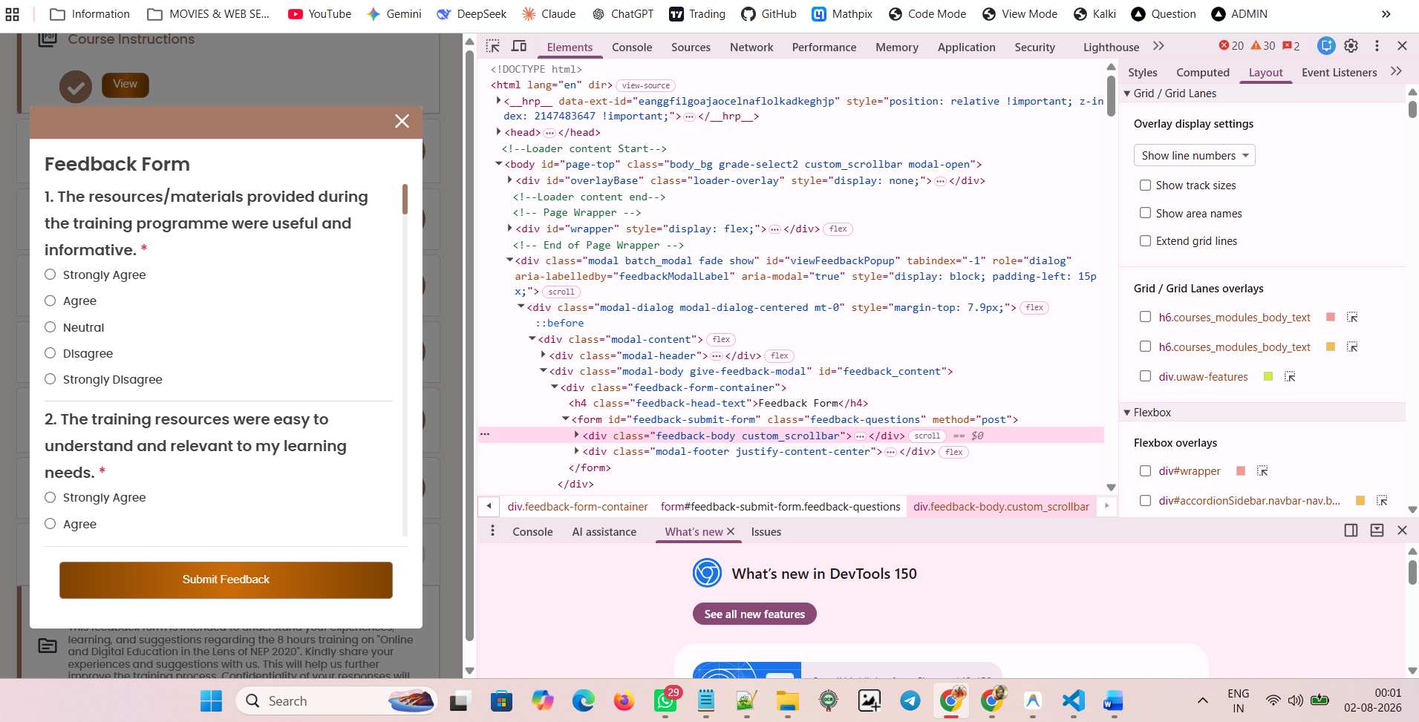

RADIO BUTTON

<input class="form-check-input" type="radio" name="multichoice_3808" id="multichoice_3808_1" value="1" required="">

<div class="feed-ans-div"><div class="form-check"><input class="form-check-input" type="radio" name="multichoice_3808" id="multichoice_3808_1" value="1" required=""><label class="form-check-label" for="multichoice_3808_1">Strongly Agree</label></div></div><div class="feed-ans-div"><div class="form-check"><input class="form-check-input" type="radio" name="multichoice_3808" id="multichoice_3808_2" value="2" required=""><label class="form-check-label" for="multichoice_3808_2">Agree</label></div></div><div class="feed-ans-div"><div class="form-check"><input class="form-check-input" type="radio" name="multichoice_3808" id="multichoice_3808_3" value="3" required=""><label class="form-check-label" for="multichoice_3808_3">Neutral</label></div></div>

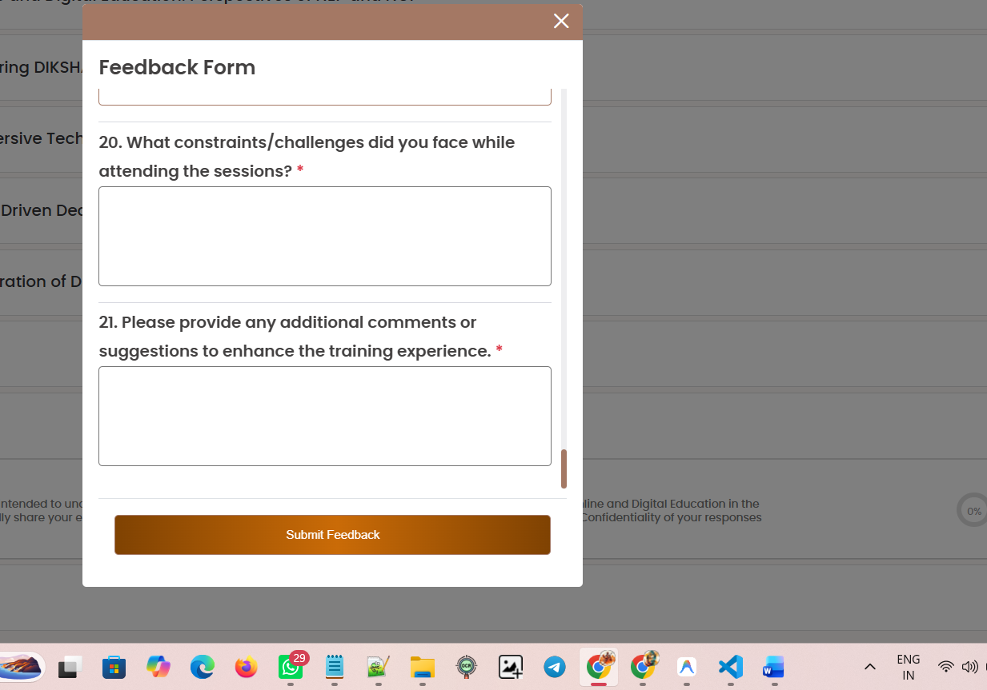

<textarea class="form-control" name="textarea_3827" rows="4" required="" data-last-active-input=""></textarea>

<div class="que-no">19. What aspects of the training could be improved? <span class="text-danger">*</span></div>

<div class="feed-ans-div"><textarea class="form-control" name="textarea_3826" rows="4" required=""></textarea></div>

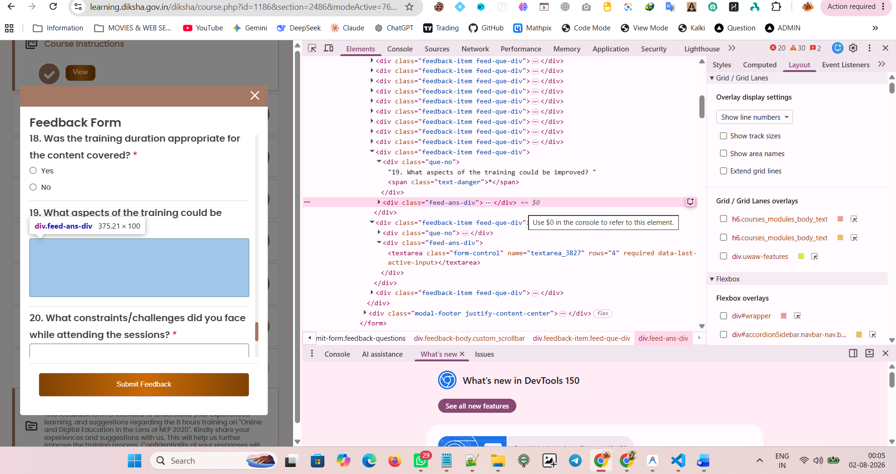

SUBMIT FEEDBACK \
<button type="submit" class="btn btn-primary w-100 submit-feed-btn" id="submitFeedbackBtn11">Submit Feedback</button>

<div class="modal-footer justify-content-center"><button type="submit" class="btn btn-primary w-100 submit-feed-btn" id="submitFeedbackBtn11">Submit Feedback</button></div>

